QUEEN MARY’S COLLEGE (AUTONOMOUS), CHENNAI- 4
POST GRADUATE DEPARTMENT OF HOME SCIENCE
REPORT ON ALUMNI MEET
2025-2026
An Alumni Meet was conducted by the Department of Home Science on 14th February 2026 at 10.00 a.m. A total of 25 alumni participated in the programme.
The event commenced with a warm and informal welcome address by Dr. C. Kalaivani Ashok, Associate Professor and Head, Department of Home Science. In addition to welcoming the alumni, she outlined the agenda for the day and appealed to the alumni to extend their support in strengthening and elevating the Department. She emphasized the importance of creating enriching learning experiences for students while equipping future graduates with employability skills and self-sufficiency.
The welcome address was followed by a self-introduction session by the alumni, which fostered interaction and reconnection. Discussions were encouraged on ways in which alumni could contribute to student welfare and departmental development. To sustain interest and inspire the gathering, a video highlighting the legacy of the Department and its achievements over the past five years was screened.
The present status and progress of the Department were further showcased through an audiovisual presentation delivered by Dr. Ananthalakshmi, Mrs. Rubini, and Mrs. Bhuvaneswari faculty of the Dept. The presentation highlighted various activities undertaken during the academic year 2025–2026, including the publication of the student-initiated magazine “Nourish and Flourish,” along with notable achievements of faculty and students.
This was followed by the release of the first draft of a Memorandum of Understanding (MoU) between Twins Digital Services India Pvt. Ltd. and the Department of Home Science, aimed at facilitating diet counselling internship opportunities for students in the coming years.
The programme concluded on a celebratory note with a cultural performance by the final-year students, organized to entertain their seniors, which was received with great enthusiasm and applause.
The meet concluded with a vote of thanks delivered by Mrs. Nisha Solomon, Associate Professor, Department of Home Science.

GLIMPSES OF ALUMNI MEET 2026

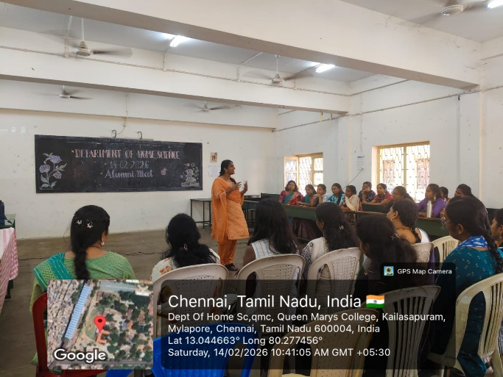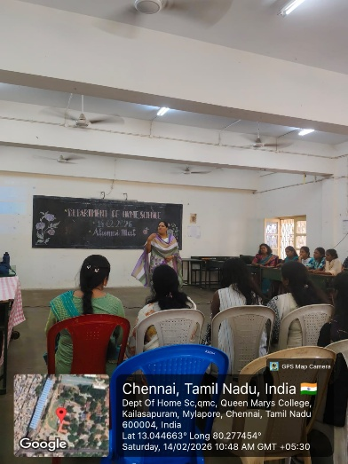
Alumni sharing their success stories to students

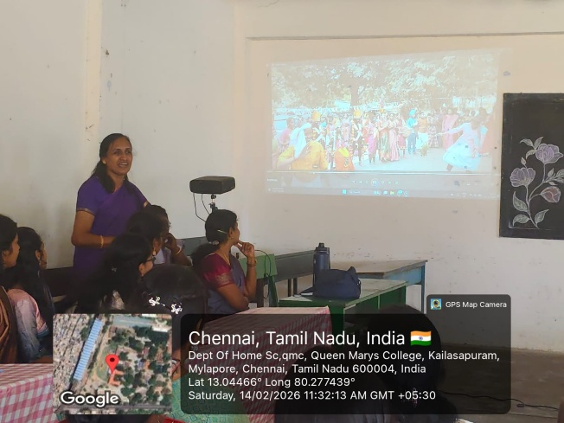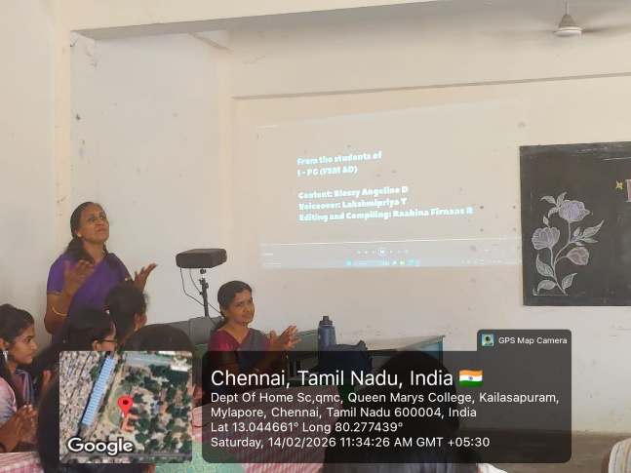
Dr. Ananthalakshmi, Associate Professor presenting Department Activities and achievement in 2025-2026

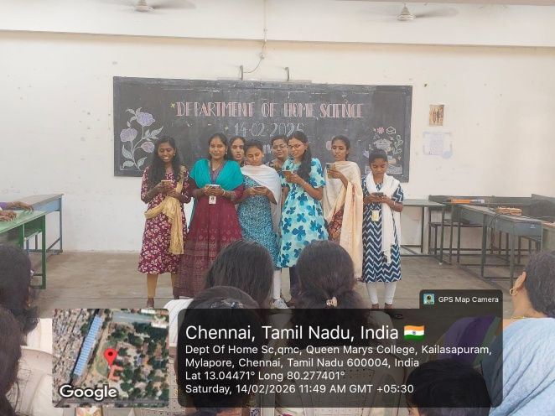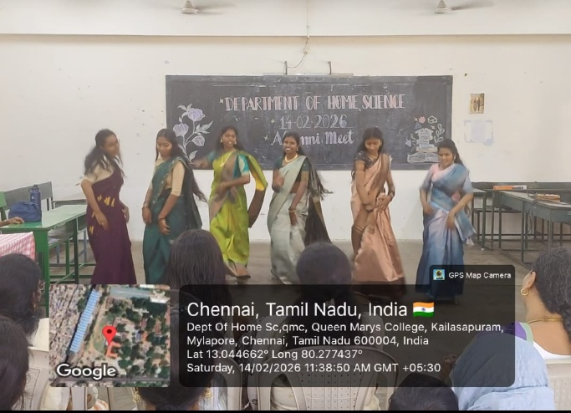
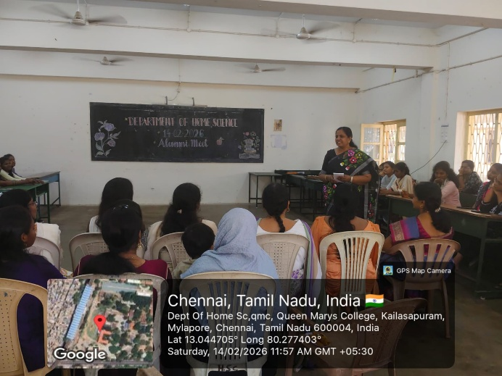
Cultural programme by students for Alumni

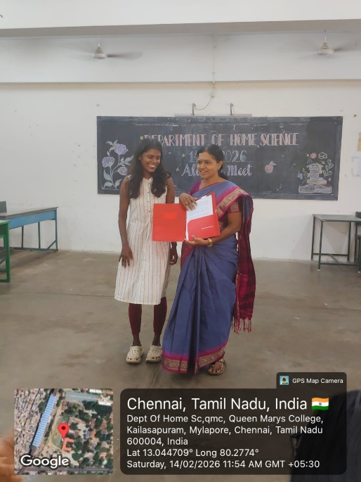
MoU signed between Twins Digital Services India Pvt. Ltd. and the Department of Home Science

