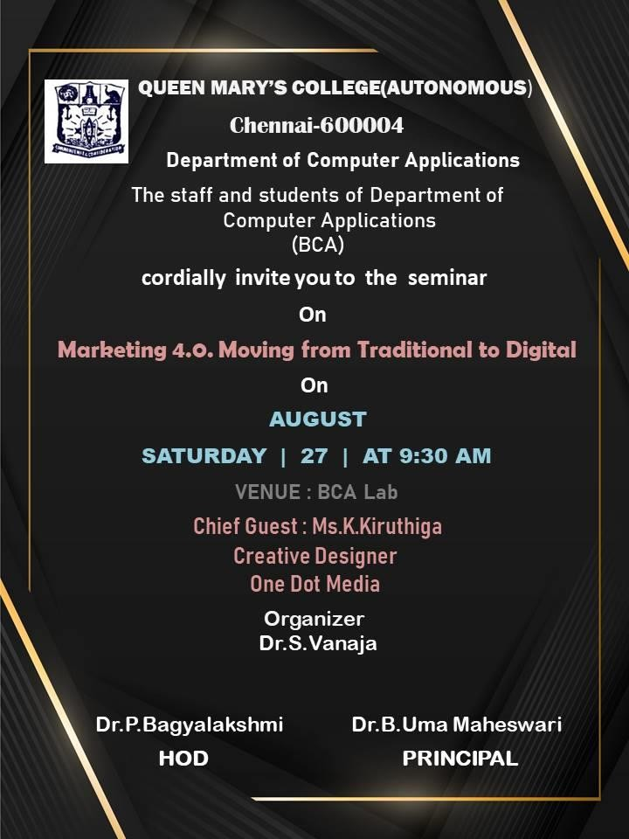

# PROGRAM SCHEDULE

* Prayer Song:

II Year BCA, Ms.Abinaya Ms.Shanmuga Priya Ms.Varsha Ms.Vidhya Shree

* Welcome Address:

Ms.Sneha, II Year BCA.

* Guest Introduction:

Ms.Hanish Fathima, II Year BCA.

* Felicitation:

Dr.P.Bagyalakshmi, Head of the Department,

Department of Computer Application.

* Keynote Address:

Ms.K.Kiruthiga, Creative Designer, One Dot Media.

* Vote of Thanks:

Ms.Mahalakshmi, II Year BCA.

* National Anthem

II Year BCA Ms.Abinaya Ms.Shanmuga Priya Ms.Varsha Ms.Vidhya Shree

# SEMINAR REPORT

The Department of Computer Application organized a seminar on August 27,2022 on “**Marketing 4.0 moving from traditional to modern”.**The event was held in the BCA LABORATORY of our college.The expert chief guest Ms.K.Kiruthiga(Creative Designer at One Dot Media) was welcomed and honoured by DR.P.Bagyalakshmi(Head of the Department)

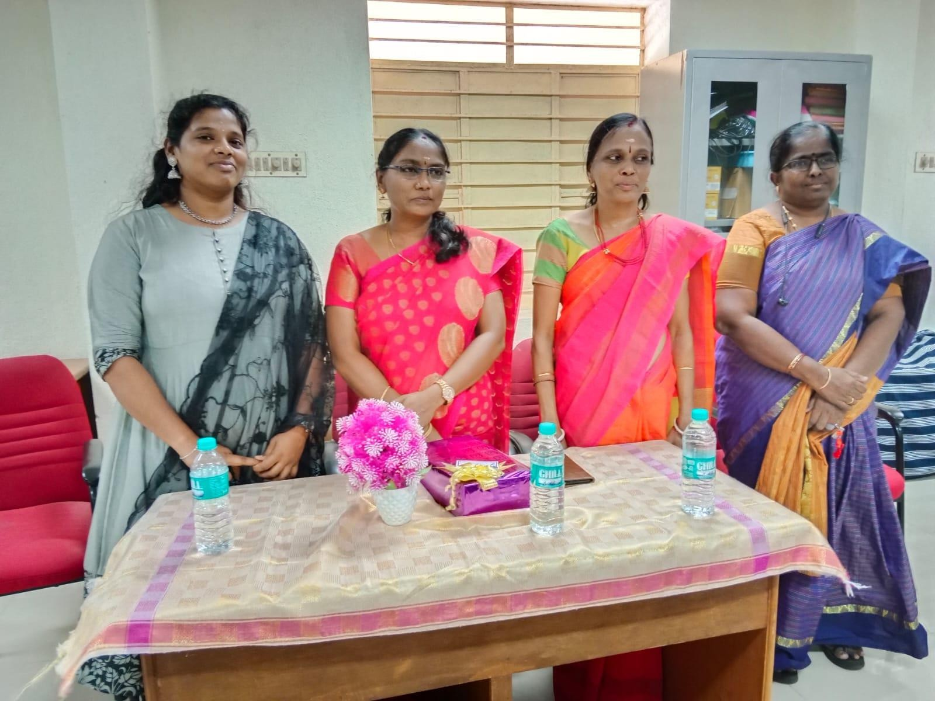

The seminar is organized for the second and third year students.Nearly 90 students participated in the seminar.The seminar started by Thamizh Thaai Vaazhthu.With an introduction about the chief guest the session started.The session was really informative.Ms.Kiruthiga done a valuable seminar with her adorable knowledge on digital marketing.Ms.Kiruthiga taught about the evolutions of marketing ,marketing types and its concepts.

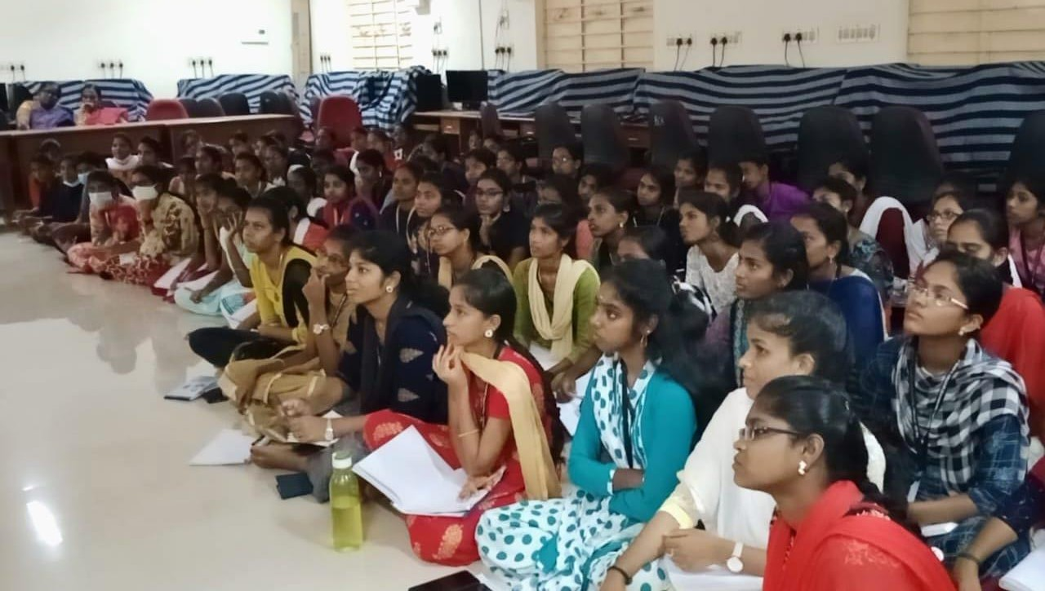

The students learnt some beneficial informations like

* Animations(2D,3D)
* Content Marketing
* Photoshops(Illustrator,Coral Draw,Adobe Indesign)
* UI\UX designing(Adobe,Figma,Sketch)
* Video editing

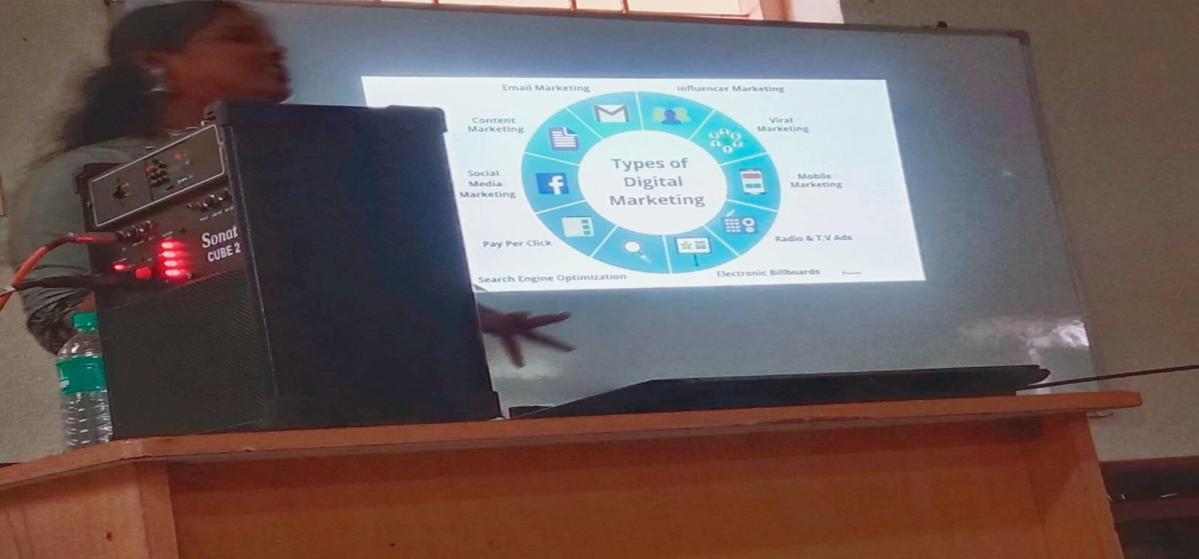

Then she shared her work experience and gave career guidance to our students.She also talked about the online teaching websites.She also gave tips to get internship.At the end of the session many students cleared their doubts about internships and career based questions.The seminar was successfully came to end by playing National Anthem.

***End of the program***

# GUEST PROFILE

Ms.K.Kiruthiga did her UG Degree BCA in Queen Mary’s College. She is currently working as Creative Designer at One Dot Media,Chennai.