**QUEEN MARY’S COLLEGE**

**DEPARTMENT OF COMPUTER APPLICATIONS**

**TECHNOLA'25 - ASSOCIATION REPORT**

The BCA Department of Queen Mary's College proudly presented 'Technola'25, a two-day event held on January 6th and 7th organized by the third-year students. The first day was a showcase of technical talent, while the second day was a fun-packed non-technical event. It was an exhibition of talents and knowledge by all the UG and PG students of the department. The valedictory function was held on 24th of January 2025 with a professional talk and some cultural events. It was a great team effort that made Technola a huge success and the highlights of the proceedings are as follows

**BYTE THE DEBATE**

**EVENT NAME**: BYTE THE DEBATE

**DATE:**06-01-2025

**JUDGES:** Dr. M. MEGALA DEVI AND Dr. I. G. ARUNA RANI

**INCHARGE FACULTY:** Dr. T. BHUVANESHWARI

**ORGANISED BY:** NIVEDHA, PADMASHREE, PRAVEENA, PREMA, SANDHIYA

As part of the Association Day celebrations, the Byte the Debate event was conducted to foster critical thinking, technical knowledge, and effective communication among students. The competition brought together undergraduate and postgraduate students, forming combined teams to engage in thought-provoking discussions on emerging trends and challenges in technology. Participants debated on contemporary topics such as AI ethics, cyber security threats, the impact of automation on employment, and the future of quantum computing. Each team was evaluated on argument strength, clarity, rebuttal effectiveness, and overall presentation. The interactive format encouraged students to analyze issues from multiple perspectives, enhancing both their technical and debating skills. A panel of judges, comprising faculty members and industry experts, assessed the debates and provided insightful feedback. The event saw spirited discussions, compelling arguments, and innovative viewpoints, making it a highly engaging and intellectual stimulating experience.

**WINNERS :**

After a thorough evaluation, the following teams were declared winners:

First Prize: Nisha. P, Parameshwari. L [III BCA]

Second Prize: Katheeja barvin.M , Rosy.B [III BCA]

Third Prize: Hemavathy. A, Kalpana .M [I BCA]

Byte the debate successfully promoted collaboration confidence, and a deeper understanding of technological advancement, making it a standout event of the day.

**TRASH2TECH**

**EVENT NAME:** TRASH2TECH

**DATE:** 06-01-2025

**JUDGES**: Mrs. G. PRIYADHARSHINI

**INCHARGE FACULTY:** A. PUNITHA

**ORGANISED BY:** NIVEDHA, PREMA, SANDHIYA, PADMASREE, PRAVEENA

As part of the Association Day celebrations, the Trash2Tech event was organized to encourage innovative thinking and sustainability among undergraduate and postgraduate students. The competition aimed to promote the concept of up cycling waste materials into functional and creative technological solutions. Participants were required to design and develop prototypes using discarded materials, demonstrating their technical skills, creativity, and environmental consciousness. The event saw enthusiastic participation, with students showcasing projects ranging from eco-friendly gadgets and repurposed electronic devices to smart home solutions using recycled components. A panel of judges evaluated the projects based on innovation, feasibility, sustainability, and presentation. The event provided a platform for students to apply their engineering knowledge while addressing environmental concerns.

**WINNERS :**

After a thorough evaluation, the following teams were declared winners:

First Prize: Simi Evangeline & Harini [II BCA]

Second Prize: Abinaiya & Shamitha [III BCA]

Third Prize: Dhivya & Sindhuja [II BCA]

**VISUAL VORTEX**

**EVENT NAME:** Visual Vortex 2025

**DATE:** 06-01-2025

**JUDGES:** Dr. M. Antony Ammal [Associate Professor]Dr. S. Leelalakshmi [Associate Professor], Department of Computer Science

**INCHARGE FACULTY:** Dr. Mary Metilda

**ORGANISED BY:** Swathi S, Ragavi A, Deva S, Priyatharshini V, Rosy B

Poster making is a creative way to visually communicate ideas, messages, or promotions. It combines text, images, colors, and design elements to grab attention and convey a clear message. Social causes, advertisements, or artistic expression, a well-designed poster should be eye-catching, informative, and easy to understand at a glance. On the competition day, each participant worked passionately on a given theme, crafting posters that were not only unique but also thought-provoking and insightful. Once the participants completed their posters, the judges eagerly awaited the presentations. Each team confidently presented their work, explaining the ideas and messages behind their posters. The judges engaged with the teams, asking insightful questions about their themes, to which the participants responded thoughtfully. After much deliberation, the judges announced the winners, recognizing the creativity and effort of all participants. The event was a celebration of artistic talent and innovative thinking.

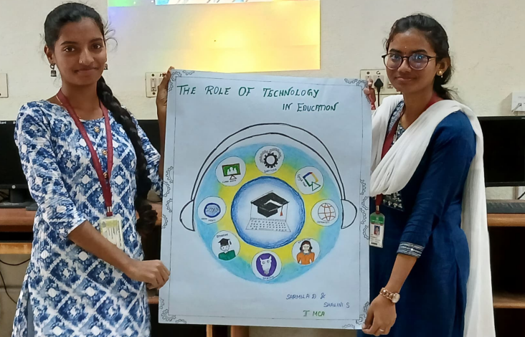

**Winners:**

After a thorough evaluation, the following teams were declared winners:

* + **First Prize:** Simi Evangeline C, Nivedha m (BCA 2nd yr)
  + **Second Prize: Thulasi. T,**Priya dharshini. R(BCA 1st yr)
  + **Third Prize:** Akshayashri. K, Gayathri. S ( BCA 3rd yr)

**VISIONX 2025**

**EVENT NAME:** VisionX 2025

**DATE:** 06-01-2025

**JUDGES:** Dr. M. Antony Ammal [Associate Professor]Dr. S. Leelalakshmi [Associate Professor], Department of Computer Science

**INCHARGE FACULTY:** Dr. Mary Metilda

**ORGANISED BY:** Swathi S, Ragavi A, Devashri S, Priyatharshini V, Rosy B

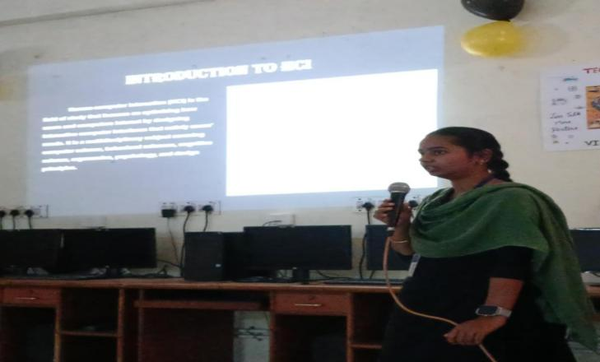The VisionX 2025 event was organized to foster creativity, technical skills, and innovation among participants. This event aimed to challenge students to think critically, showcase their talents, and explore new perspectives through engaging activities and competitions.The objective of the event was to encourage out-of-the-box thinking and innovation; Provide a platform for students to showcase their technical and artistic skills, Trash2Tech successfully fostered environmental awareness, problem-solving skills, and teamwork, making it a highlight of the Association Day festivities, Foster teamwork, collaboration, and problem-solving abilities, Inspire participants to embrace creativity in their respective fields.The event witnessed enthusiastic participation from UG & PG students, with various teams competing in diverse categories. The competitions were judged based on creativity, presentation, originality, and technical execution. The panel of esteemed judges, including Dr**. M. Antony Ammal, Dr. S. Leelalakshmi**, brought their expertise to evaluate the outstanding work presented by the participants.

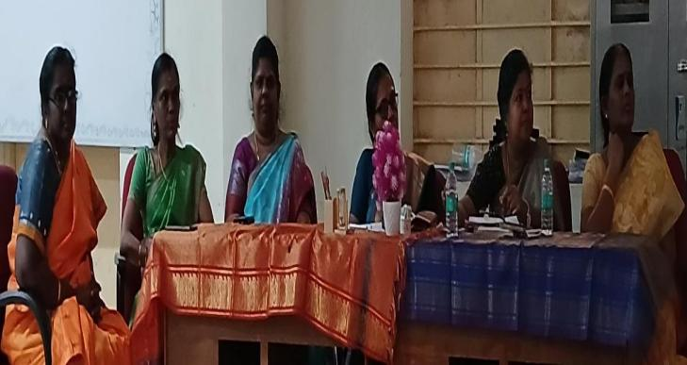

**Winners:**

After thorough evaluation, the following teams were declared winners:

**First Prize:** kiruthika E [ BCA 3rd year ]

**Second Prize:** Merlin S [ BCA 3rd year ]

**Third Prize:** Vanmathi S [ BCA 3rd year ] & Jayashree [ MCA 2nd year ]

**Rangoli**

**Competition on the Theme of AI and Technology**

A Rangoli competition centered on the theme of **Artificial Intelligence (AI) and Technology** is an innovative way to blend traditional art with modern advancements. This competition encourages participants to express their creativity while illustrating the impact of AI and technology in our daily lives.Participants showcased various aspects of AI and technology through their Rangoli designs, such as:

* **Robotics & Automation** – Depicting humanoid robots, industrial automation, and futuristic machines.
* **Artificial Intelligence** – Representing neural networks, AI-driven innovations, and virtual assistants.
* **Space & Technology** – Illustrating AI-powered space exploration, satellites, and futuristic spacecraft.
* **Smart Cities & IoT** – Visualizing smart homes, connected devices, and urban AI solutions.
* **Cyber security & Data** – Showcasing digital security, encryption, and the role of AI in cyber security

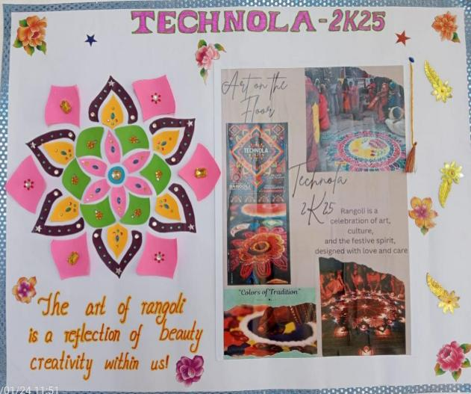

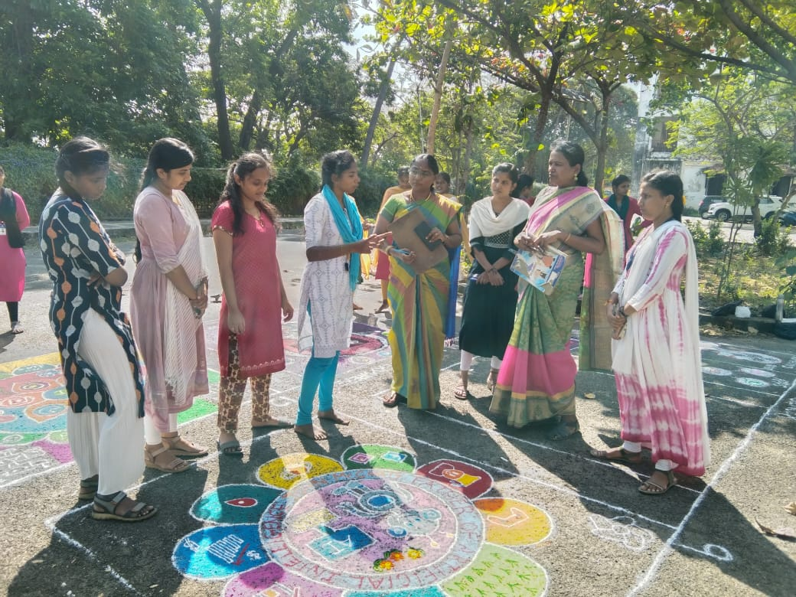

**FIRELESS FLAVOUR FEST**

**EVENT NAME:** FIRELESS FLAVOUR FEST

**DATE:**07-01-2025

**JUDGES:** JAYALAKSHMI AND VASUKI

**INCHARGE FACULTY:** MARY METILDA

**ORGANISED BY:** AKSHAYA, THULASI, APARNA, BHAKIYA, SWETHA

The *Cooking Without Fire* event was organized to promote creativity, healthy eating habits, and the importance of nutrition among participants. The event aimed to showcase innovative culinary skills without the use of conventional cooking methods involving fire or heat. The event witnessed enthusiastic participation from UG & PG BCA students. Participants were grouped into teams to fostering collaboration and creativity. Dishes were judged based on presentation, taste, creativity, cleanliness, and effective usage of ingredients. The panel of judges included all the participants, who brought their expertise to the evaluation process. Participants showcased a variety of innovative dishes, including sweet, savories, beverages and more.

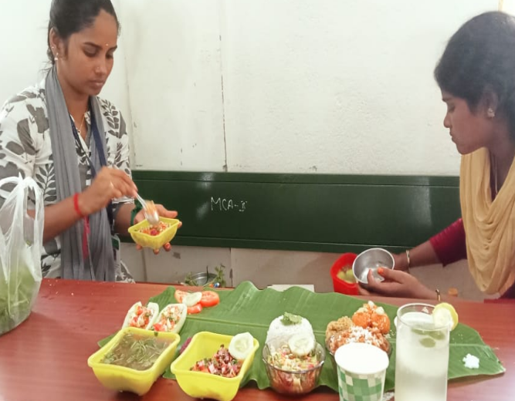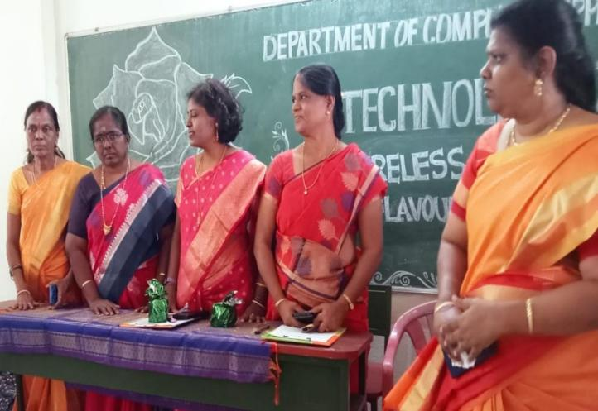

**Winners:**  
 After a thorough evaluation, the following teams were declared winners:

* + **First Prize:** Jaya sri &vinothini [II BCA]
  + **Second Prize:** *Tharani & Praveena , Vasanthasena & Uma [III BCA]*
  + **Third Prize:** Uma & Monika , Abinaya & Soundarya [II MAC]

**TABLETOP DECOR**

**EVENT NAME:** Tabletop Decor (Vegetable Carving)

**DATE:** 07-01-2025

**JUDGES:** Jayalakshmi and Vasuki

**INCHARGE FACULTY:** Punitha

**ORGANISED BY:** Gayathri, Lavanya, Roja, Bharathi, Narmatha

The Tabletop Decor (Vegetable Carving) event was organized to promote artistic expression, creativity, and the importance of aesthetic presentation in culinary arts. The event aimed to encourage participants to explore the art of vegetable carving as a medium of expression while also emphasizing the significance of food presentation in culinary traditions. Objective is to, Encourage creativity and innovation in food presentation. Promote the art of vegetable carving as a skillful and decorative technique. Enhance patience, precision, and artistic ability among participants., Foster teamwork and collaboration through group participation. Participants showcased a variety of impressive carvings, including floral designs, animal figures, and abstract patterns, using a range of fresh vegetables. The event displayed the immense potential of food as an artistic medium.

**Winners:**

First Prize: Kirthika.T & yamuna.B [II MCA]

Second Prize: sowmiya.V & sabitha.s [II BCA]

Third Prize: katheeja & nilofer (III BCA) ,Simi Evangeline & keerthavarshini (II BCA)

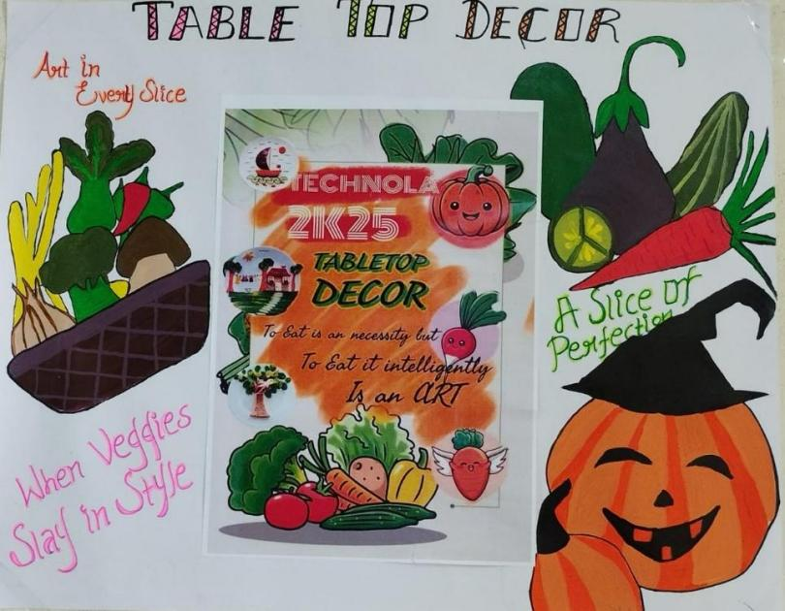

**Debugging Event Report**

**Event Name:** TechNola-25

**Competition:** Debugging Challenge

**Incharge Mam:** Dr. J .Jecinth Salome

**Event Incharge:** Katheeja Barvin M( 3rd year )

**Date:** 06.01.2025

**Venue:** BCA 1st year class

The goal of the debugging competition was to identify and resolve code-related issues within a set time frame. Participants were required to demonstrate strong problem-solving skills, code analysis, and quick-thinking abilities. Objective is to enhance problem-solving and critical-thinking skills, Improve ability to debug under pressure, Gain valuable experience in real-time code troubleshooting.

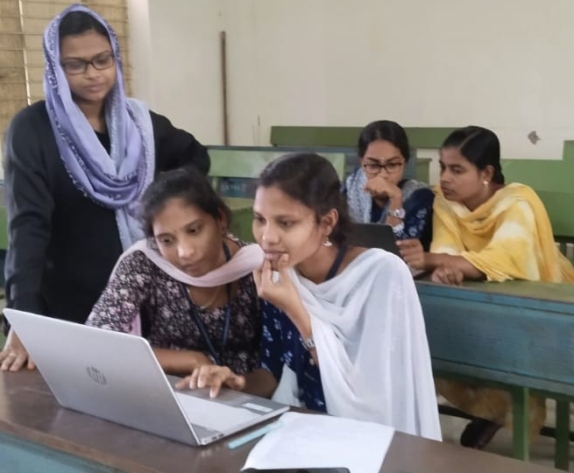

**TECH LINK CONNECTION**

**EVENT NAME:** TECH LINK CONNECTION

**DATE:** 06-01-2025

**JUDGE & INCHARGE FACULTY:** Vanaja Mam

**ORGANISED BY:** Team Incharge – Narmatha

**TEAM MEMBERS:** Parameshwari, Nisha, Amulu, Madhumitha

The Tech Link Connection event was designed to enhance technical knowledge, logical thinking, and problem-solving skills among participants. This event challenged students to connect technology-related terms, concepts, and innovations in a creative and competitive format. Objective is to encourage analytical thinking and problem-solving in technology, foster teamwork and collaboration among participants, improve pattern recognition and quick decision-making, and provide an engaging and interactive learning experience. The event saw enthusiastic participation from UG & PG BCA students. Participants were grouped into teams and tasked with solving technology-based puzzles and logical connections. The event was judged by Dr.S.Vanaja, who evaluated teams based on accuracy, speed, and creativity in linking technical concepts.

**Winners:**

🏆 First Place (II BCA): Shobana, Sharmiladevi, Sandhiya,

🥈 Second Place (II BCA): Abiniya, Archana, Bhuvaneshwari

🥉 Third Place (I BCA): Kumutha, Nirosha, Thulasi

ZAP VERT (AD ZAP)

**EVENT NAME**: ZAP VERT (ADAZAP)  
**DATE**: 07-01-2025  
**JUDGE**: Hemavathy Mam, Suganthi Mam  
**IN-CHARGE FACULTY**: Bhuvaneshwari Mam  
**ORGANISED BY**: Aarthi, Mohana Priya, Abinaya, Shenga

The Ad zap event was organized to celebrate creativity, strategic thinking, and presentation skills through a fun and engaging advertisement competition. This event aimed to inspire participants to showcase their innovation in advertising, whether through humor, product creativity, or unique approaches in promoting a fictional product. Objective was to Foster creativity and originality in advertisement creation, Enhance communication and persuasive skills among participants, Encourage teamwork and collaboration in creating impactful ad campaigns, Develop participants’ understanding of advertising as both a business and an artistic tool. Participants used a variety of formats, including skits, digital presentations, and mock commercials, all showcasing their creative prowess. The event truly highlighted the versatility of advertising as an art form and a tool for communication.

**Winners:**

* **First Prize**: Jaya P (MCA-II)
* **Second Prize**: Priyadharshini (BCA I) and Kumari (BCA III)
* **Third Prize**: Yashitha (MCA I)

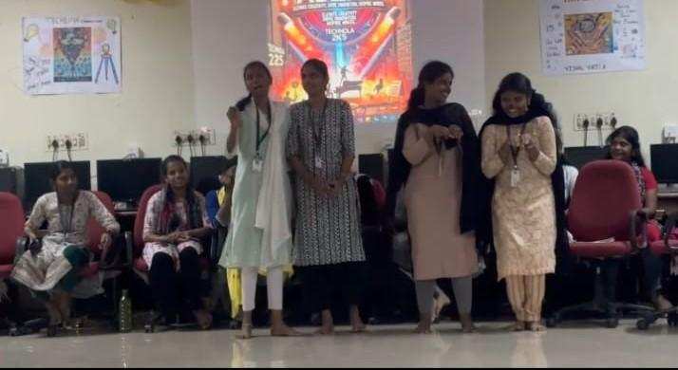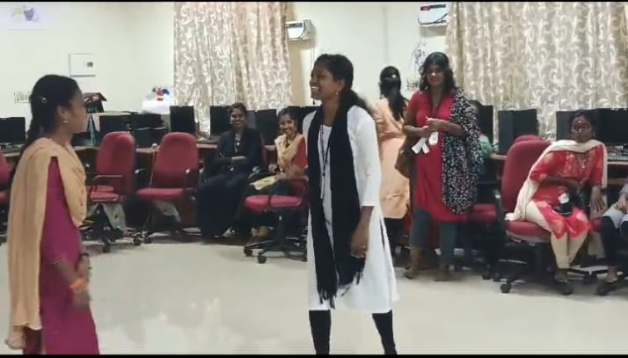

**MEHNDI MASTERPIECE CONTEST**

**EVENT NAME:** Mehndi Masterpiece Contest

**DATE:** 07-01-2025

**JUDGE:** Rama mam

**INCHARGE FACULTY:** Jacinth

**ORGANISED BY:** Karthika, Dharshini, Tharani, Divya madhi

The Mehndi Masterpiece Contest was organized to celebrate artistic talent, creativity, and cultural heritage through the intricate art of Mehndi design. This event aimed to encourage participants to explore the beauty of Mehendi as a traditional and contemporary form of artistic expression. Objective is toEncourage creativity and innovation in Mehndi design, Promote Mehndi as a skillful and decorative art form, Enhance patience, precision, and artistic ability among participants, Foster teamwork and collaboration through group participation. Participants showcased a variety of stunning Mehndi designs, including traditional motifs, modern fusion patterns, and festive based designs. The event highlighted the immense potential of Mehndi as an artistic and cultural expression.

**Winners:**

First Prize:Jaya P (MCA-II)

Second Prize:Priyadharshini (BCA I) and kumari(BCA III)

Third Prize:Yashitha(MCA I)

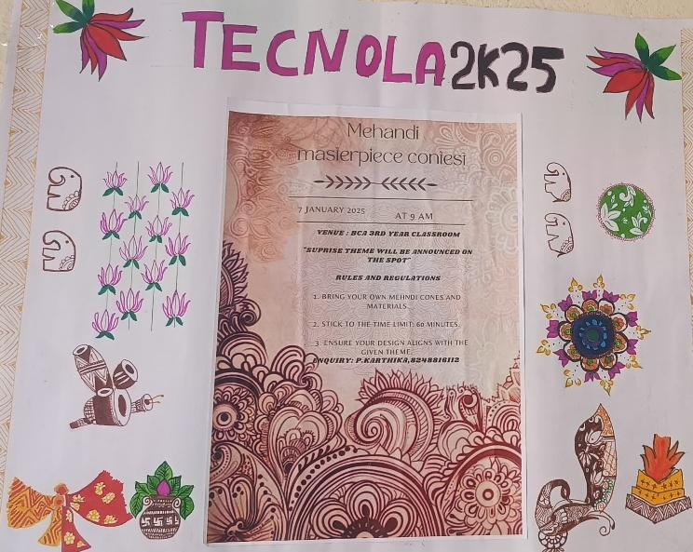

**Valedictory Ceremony**

The **Valedictory Ceremony** of the Technola Association Day was a grand celebration that brought together students and faculty to recognize achievements, showcase talents, and promote collaboration in technology. The event featured an inspiring speech on Evolving technologies in IT Industry by the chief guest, Mr. Shakthivel, who shared insights on innovation and industry trends. Highlights included a video presentation on the association’s journey, a felicitation ceremony, and an overall trophy presentation for outstanding students. Students performed cultural events like technical singing and dance which added vibe to the students. Faculty members also appreciated student efforts, encouraging them to continue excelling. The event concluded with a vote of thanks, leaving a lasting impact on participants and reinforcing the spirit of learning and teamwork.

