**TANCET- EXAM PREPARATION**

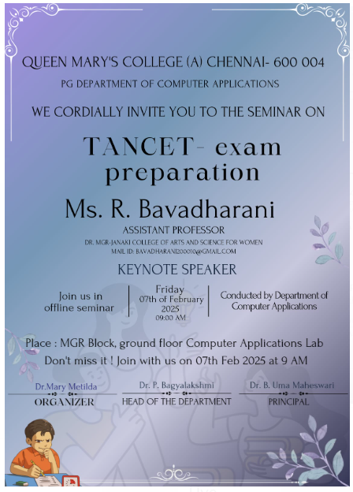

**Report on Seminar: Tips, Strategies, and Guide for TANCET Exam**

**Organized by**: Department of Computer Applications  
**Date**: 07th February 2025  
**Venue**: BCA Lab  
**Time**: 9:00 AM

**Program Overview**

The Department of Computer Applications organized a seminar on **"Tips, Strategies, and Guide for TANCET Exam"** to assist students in preparing for the Tamil Nadu Common Entrance Test (TANCET). The seminar aimed to provide insights into the exam structure, study techniques and guidance on overcoming exam stress.

The event was attended by students from the department, faculty members, and the distinguished guest speaker, **Ms. Bavadharani R**, Assistant Professor at **Dr. MGR-Janaki College of Arts and Science for Women**.

The seminar commenced at 9:30 AM with a welcome address, followed by the keynote speech, a detailed presentation, a Q&A session, and concluded with a vote of thanks. The event began with a warm **welcome speech.** The HOD and faculty members emphasized the need for structured preparation and how such events are crucial for building confidence in the students.

The HOD, along with the faculty members, presented a **gift** to Ms. Bavadharani R as a token of appreciation for her valuable participation in the seminar.

**Keynote Speech by Ms. Bavadharani R**

Ms. Bavadharani R began her speech by thanking the Department of Computer Applications for inviting her and providing a platform to interact with students. She shared her insights on the following aspects of TANCET preparation:

#### **1. TANCET Exam Overview**

Ms. Bavadharani provided a detailed overview of the **TANCET exam**, explaining its structure and the subjects covered:

* **Sections**: Quantitative Aptitude, Logical Reasoning, Verbal Ability, and Computer Awareness.
* **Marking Scheme**: The importance of understanding the number of questions and the negative marking system was emphasized.
* **Scoring Details**: She explained how the exam is scored, highlighting the importance of accuracy and time management.

#### **2. Recommended Books and Study Materials**

Ms. Bavadharani advised students on the books and resources they should use for each section of the exam. She suggested the following:

* **Quantitative Aptitude**: Books by R.S. Agarwal (Quantitative Aptitude) and Arun Sharma.
* **Logical Reasoning**: Books by M.K. Pandey and R.S. Agarwal.
* **Verbal Ability**: Books by Norman Lewis (Word Power Made Easy) and Barron's.

#### **3. Step-by-Step Guide on How to Apply for TANCET**

Using a **PowerPoint presentation (PPT)**, Ms. Bavadharani walked the students through the **application process** for the TANCET exam. She covered:

* How to register online for TANCET.
* The required documents for submission.
* Important dates to remember.
* Steps for filling out the application form and uploading necessary details.

#### **4. Exam Preparation Tips**

She shared practical **study tips** to help students excel in the TANCET exam:

* **Time Management**: Plan study sessions, allocate time to weaker subjects, and focus on mock tests.
* **Regular Revision**: Revision is key, and students should regularly revisit difficult topics.

### ****Q&A Session****

After the keynote address, Ms. Bavadharani answered several questions raised by the students. The questions were related to specific topics in the TANCET exam, such as:

* How to tackle the toughest sections of the exam.
* Time allocation strategies during the exam.
* Tips for staying calm and composed during the exam.

Ms. Bavadharani provided insightful answers, offering encouragement and practical solutions to help the students approach their preparations with confidence.

### ****Speech on IT Industry Experience****

Ms. Bavadharani also shared her experiences working in the **IT industry** and how it has shaped her career. She spoke about the skills required to thrive in the IT sector and the importance of staying updated with the latest technological advancements. She encouraged students to not only focus on exams but also explore opportunities in the IT industry, providing guidance on how they can approach internships and job opportunities.

