The 108th Annual Sports Day commenced with a warm welcome from the principal, setting the tone for a day filled with athletic fervor. , graced the occasion with a

Felicitation address, followed by a thought-provoking speech from the esteemed chief guest, Dr.Johnson Prem Kumar

The grand inauguration saw the hoisting of the college flag and the igniting of the Olympic torch, officially declaring the Sports Day open. A captivating Color March past, skillfully executed by various departments, unfolded before judges Dr.R Desingurajan, Director of Physical Education, DB Jain College, and Dr. K.S. Sridhar, Director of Physical Education, Pachayappa’s College

**Dr. V. Sujitha, head and Director of Physical Education,** presented an insightful annual report highlighting a spectrum of intramural events that engaged students, teaching staff, and non-teaching staff alike. The cultural segment dazzled with displays of karate, yoga, silambam, and aerobics, with lezium, showcasing the diverse talents of the students.

As the day reached its pinnacle, the chief guest and principal took center stage to honor and distribute prizes to the deserving winners. Special recognition was extended to the dedicated members of the college sports committee and coaches who played pivotal roles in nurturing talent.

The ceremonial lowering of the college flag marked the culmination of the Sports Day, symbolizing the end of a day filled with enthusiasm. The college principal graciously handed over the flag to the Physical Director, bringing a fitting closure to the event. Miss.S.Sandhya, 3Rd year DPHS,The Sports Secretary expressed heartfelt gratitude in the concluding vote of thanks, acknowledging the collaborative efforts that contributed to the success of the 108th Annual Sports Day.

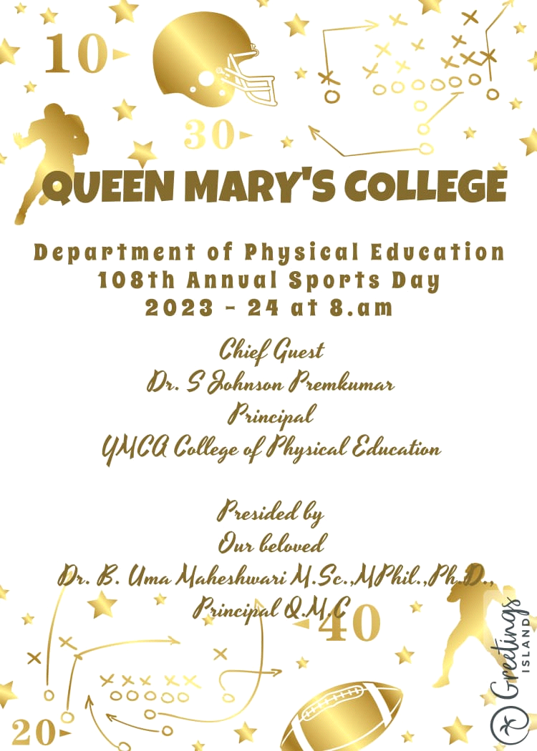

|  |  |  |  |  |
| --- | --- | --- | --- | --- |
|  | | | | |
| **DEPARTMENT OF PHYSICAL EDUCATION** | | | | |
| **SPORTS DAY RESULTS 2023-2024** | | | | |
| **GAME: CHESS** | | | | |
| **WINNER** | | | **RUNNER** | |
| **S.NO** | **NAME** | **CLASS** | **NAME** | **CLASS** |
| 1 | A. SRIDEVI | II B.COM CS | S. PREETHI | II B.A HIS |
| **GAME: CARROM** | | | | |
| 1 | S. AUGUSTINA | II B.A SOCIOLOGY | A. NETHRA DEVI | II B.A ECONOMICS |
| 2 | S. FIZATHABASOM | III B.A SOCIOLOGY | M. KUMAIRUC MARIJOHN | II B.A ECONOMICS |
| **GAME: BADMINTON** | | | | |
| 1 | B. BLESSY VEFELIN RAJ | II M.A ENGLISH | J. METTILDA JOSEPHINE | III B.COM (CS) |
| 2 | S. ABI | III B.A ENGLISH | S. SOWNDHARIYA | III B.COM (CS) |
| **GAME: TABLE TENNIS** | | | | |
| 1 | R. NIVEDA | III B.COM (SH-II) | P. ANGELIN | I MCA |
| 2 | U. VIDHYASREE | II B.COM | V. RANJINI | III BCA |
| **GAME: VOLLEY BALL** | | | | |
| 1 | S. SUMATHI | II M.A SOCIOLOGY | R. JEEVA | II B.COM |
| 2 | R. POOJA PRIYA | II B.A SOCIOLOGY | R. SRINIDHIMONIKA | I B.COM |
| 3 | M.MANVITHA | II B.A SOCIOLOGY | S. RAJADHARANI | I B.COM |
| 4 | K.R. AMRITHA | II M.A SOCIOLOGY | R. MOHANA | I B.COM |
| 5 | V. RAMYA | II M.A SOCIOLOGY | K. SUJATHA | I B.COM |
| 6 | C. VINODHINI | II M.A SOCIOLOGY | G. AKSHIKA | I B.COM |
| 7 | M. AKSHAYA | II M.A SOCIOLOGY | S. SRATHIKA KAMALA | I B.COM |
| 8 | K. MANJULA | II M.A SOCIOLOGY | G. YUGAPRIYA | I B.COM |
| 9 | S. JEBAQUEEN | II B.A SOCIOLOGY | K. SAPTHAMI | II B.COM |
| 10 | S. SWETHA | II B.A SOCIOLOGY | S. AKILA | II B.COM |
| 11 | J. LOGITHA | II B.A SOCIOLOGY | K. KALAISELVI | I B.COM |
| 12 | M. LOKESHWARI | II B.A SOCIOLOGY | G. SHALINI | I B.COM |
| **GAME:KHO-KHO** | | | | |
| 1 | R. SELVAM | I M.SC CHEMISTRY | K. SWETHA | I B.A TAMIL |
| 2 | K. SEETHALAKSHMI | II B.SC CHEMISTRY(T/M) | S. GIRIJA | II B.A TAMIL |
| 3 | E. PRABAVATHI | II B.SC CHEMISTRY(T/M) | M. LOGESHWARI | II B.A TAMIL |
| 4 | P. KEETHIGA | II B.SC CHEMISTRY(T/M) | L. ABINAYA | II B.A TAMIL |
| 5 | H. ASMA | III B.SC CHEMISTRY | V. SUSHI | II B.A TAMIL |
| 6 | P. AARTHI | III B.SC CHEMISTRY | E. EZHILARASI | II B.A TAMIL |
| 7 | R. KALYARASI | II B.SC CHEMISTRY | R. RESHMA | II B.A TAMIL |
| 8 | S. SWETHA | III B.SC CHEMISTRY (T/M) | D. INDHUMATHI | III B.A TAMIL |
| 9 | G. GUNATHYA | I B.SC CHEMISTRY | P. VINOBHARATHI | III B.A TAMIL |
| 10 | E. SOROJINI | I B.SC CHEMISTRY | M. CHENNAMMAL | III B.A TAMIL |
| 11 | D. SELVA KUMARI | II B.SC CHEMISTRY (T/M) | P. JEEVITHA | III B.A TAMIL |
| 12 | E. ATCHAYA | I B.SC CHEMISTRY (T/M) | S. INDHUMATHI | III B.A TAMIL |
| **GAME: KABADDI** | | | | |
| 1 | R. SONA | I M.A TAMIL | A. SUTHI | II B.A SOCIOLOGY |
| 2 | S. SAKTHI PRIYA | I M.A TAMIL | K. SEVVANTHI | II B.A SOCIOLOGY |
| 3 | A. HEMALATHA | III B.A TAMIL | S. PRIYADHARSHINI | II B.A SOCIOLOGY |
| 4 | P. VINOBHARATHI | III B.A TAMIL | M. SABARI | I B.A SOCIOLOGY |
| 5 | D. INDHUMATHI | III B.A TAMIL | N. HARINI | II B.A SOCIOLOGY |
| 6 | R. VAISHNAVI | III B.A TAMIL | R. DHARSHINI | I B.A SOCIOLOGY |
| 7 | V. THIRISHA | II B.A TAMIL | K. GOWRISELVAM | II B.A SOCIOLOGY |
| 8 | D. SABITHA | II B.A TAMIL | K. PAVITHRA | II B.A SOCIOLOGY |
| 9 | S. MAHALAKSHMI | II B.A TAMIL | J. LOGITHA | II B.A SOCIOLOGY |
| 10 | T. INDHUMATHI | II B.A TAMIL | S. RENUKADEVI | III B.A SOCIOLOGY |
| 11 | B. KALAISELVI | II B.A TAMIL | B. SOUDARIYA | III B.A SOCIOLOGY |
| 12 | T. KASTHURI | I B.A TAMIL | M. JAYALAKSHMI | I B.A SOCIOLOGY |
| **ATHLETICS** | | | | |
|
| **100 MTS** | FIRST PLACE | U. AMUTHAMOZHI | I B.SC PHYSICS | |
| SECOND PLACE | P. KEERTHIGA | II B.SC CHEMISTRY | |
| THIRD PLACE | G. PRIYADHARSHINI | III B.COM GENERAL | |
| **200 MTS** | FIRST PLACE | R. SAI PRATHIBHA | III B.A ECONOMICS | |
| SECOND PLACE | R. NAVEENA | I B.A ENGLISH | |
| THIRD PLACE | N. NETHRA SRI | I B.COM GEN (SH-II) | |
| **400 MTS** | FIRST PLACE | R. SAIPRATHIBHAA | III B.A ECONOMICS | |
| SECOND PLACE | D. SABITHA | II B.A TAMIL | |
| THIRD PLACE | D. JAYA PRIYA | II M.A HISTORY | |
| **800 MTS** | FIRST PLACE | S. JEBAQUEEN | II B.A SOCIOLOGY | |
| SECOND PLACE | E. EZHILARASI | II B.A TAMIL | |
| THIRD PLACE | M. GOWSALYA | II B.A ECONOMICS | |
| **1500 MTS** | FIRST PLACE | S. JEBAQUEEN | II B.A SOCIOLOGY | |
| SECOND PLACE | M. GOWSALYA | II B.A ECONOMICS | |
| THIRD PLACE | S. SOWATHI | I B.A ECONOMICS | |
| **4x100 MTS RELAY** | FIRST PLACE | R. SELAM | I M.SC CHEMISTRY | |
| H. ASMA | III B.SC CHEMISTRY | |
| P. KEERTHIGA | II B.SC CHEMISTRY | |
| E. PRABHAVATHI | II B.SC CHEMISTRY | |
| SECOND PLACE | H. AZEEMA | I B.A ECONOMICS | |
| K. SRIMATHI | I B.A ECONOMICS | |
| G. R. RAMYA | I B.A ECONOMICS | |
| S. DEVIKIRUBA | I B.A ECONOMICS | |
| THIRD PLACE | G. KEERTHIKA | III B.COM CS | |
| K. DEEPIKA | III B.SCOM CS | |
| S. NISHANTHINI | III B.COM CS | |
| M. ANGELMARY | II B.COM CS | |
| **FIELD EVENT** | | | | |
| **STANDING BROAD JUMP** | FIRST PLACE | R. SAI PRATHIBHA | III B.A ECONOMICS | |
| SECOND PLACE |  |  | |
| THIRD PLACE |  |  | |
| **JAVELINE THROW** | FIRST PLACE | I. JAQULIN | II. B.COM GEN (SH-II) | |
| SECOND PLACE | R. SELVAM | I M.SC CHEMISTRY | |
| THIRD PLACE | S. AKILA | II B.COM GEN (SH-II) | |
| **SHOT PUT** | FIRST PLACE | R. HARI PRIYA | III B.SC HOME SCIENCE NFSMD | |
| SECOND PLACE | SUMATHI | II M.A SOCIOLOGY | |
| THIRD PLACE | S. ANANTHI | B.COM GEN | |
| **DEPARTMENT OF PHYSCIAL EDUCATION HEALTH EDUCATION AND SCIENCE SPORTS DAY RESULTS 2023-2024** | | | | |
|
|
|
| **GAME: VOLLEY BALL** | | | | |
| **WINNER** | | | **RUNNER** | |
| **S.NO** | **NAME** | **CLASS** | **NAME** | **CLASS** |
| 1 | M. NIVETHA |  | K. PRIYA DHARSHINI |  |
| 2 | S. NIRMALADEVI |  | P. PRAGATHI |  |
| 3 | EM. SONALEE |  | P. REVATHI |  |
| 4 | M. SNEGA |  | S. GUNASREE |  |
| 5 | R. SNEHA |  | G. NARMATHA |  |
| 6 | A. DEVIPRIYA |  | A. PRIYANKA |  |
| 7 | S. SUMITHRA |  | S. SARASWATHI |  |
| 8 | S. SUBA |  | R.S ABISHA |  |
| 9 | S. SWATHIKA |  | V.P KEERTHANA |  |
| 10 | G. MALINE |  | K. MIRNALINI |  |
| 11 | R. BOOMIKA |  | NITHYASREE |  |
| 12 | K. PRIYANKA |  | R. YAMINI |  |
| **GAME: KHO-KHO** | | | | |
| **WINNER** | | | **RUNNER** | |
| **S.NO** | **NAME** | **CLASS** | **NAME** | **CLASS** |
| 1 | R. SOWMIYA |  | R. ABI |  |
| 2 | M. MOUNIKA |  | S. PAVITHRA |  |
| 3 | SANDHIYA MADHAN |  | K. PRIYANKA |  |
| 4 | S. PRITHISHA |  | N. ANANDHI |  |
| 5 | A. SUGANTHEESWARI |  | M. JAYASRI |  |
| 6 | R. SARASWATHY |  | P. NIVETHA |  |
| 7 | K. ROHINI |  | S. SUBA |  |
| 8 | SANTHIYA MOHAN |  | S. SWATHIKA |  |
| 9 | I. SANTHANALAKSHMI |  | M. SNEGA |  |
| 10 | P. SUJITHRA |  | R. SNEHA |  |
| 11 | G. AKSHAYA |  | S. ROOBINI |  |
| 12 | M. REVATHI |  | S. MARI SELVI |  |
| 13 | P. DHARANYA |  | S. VASANTHA PRIYA |  |
| 14 | NANDHINI |  | S. KEERTHIKA |  |
| 15 | V. THULASI |  | S. NIRMALA DEVI |  |
|  |  |  |  |  |
| **GAME: KABBADI** | | | | |
| **WINNER** | | | **RUNNER** | |
| **S.NO** | **NAME** | **CLASS** | **NAME** | **CLASS** |
| 1 |  |  | J. USHA |  |
| 2 |  |  | J. VINISHA |  |
| 3 |  |  | M. SHAKTHI PRIYA |  |
| 4 |  |  | K. MISNALINI |  |
| 5 |  |  | M. THIRU SELVI |  |
| 6 |  |  | K. KAYALVIZHI |  |
| 7 |  |  | K. PRIYADHARSHINI |  |
| 8 |  |  | A. SWATHI |  |
| 9 |  |  | S. SWATHIKA |  |
| 10 |  |  | C. DURGA |  |
| 11 |  |  | R. YAMINI |  |
| 12 |  |  | P. AARTHI |  |
| **ATHLETICS** | | | | |
|
| **100 MTS** | FIRST PLACE | A. KAVIPRIYA | II DPHS | |
| SECOND PLACE | M. JAYASRI | II DPHS | |
| THIRD PLACE | S. SUBA | III DPHS | |
| **5000 MTS** | FIRST PLACE | T. MAGESHWARI | II PHS | |
| SECOND PLACE | J. AYASRI | III PHS | |
| THIRD PLACE | R. HEMALATHA | II PHS | |
| **SHOT PUT** | FIRST PLACE | ARCHANA | I DPHS | |
| SECOND PLACE | S. SUBA | III DPHS | |
| THIRD PLACE | P. MERLIN | III DPHS | |
| **STANDING BROAD JUMP** | FIRST PLACE | S. SUBA | III rd YEAR | |
| SECOND PLACE | C. DURGA | I st YEAR | |
| THIRD PLACE | M. JAYASRI | III rd YEAR | |
| **4x400 MTS RELAY** | FIRST PLACE | S. SUBA | III rd DPHS | |
| S. KEERTHIKA | III rd DPHS | |
| S. SANDHYA | III rd DPHS | |
| M. JAYASRI | III rd DPHS | |
| SECOND PLACE | R. SARASWATHI | II nd DPHS | |
| R. UMA MAHESHWARI | II nd DPHS | |
| A. SUGANTHEESWARI | II nd DPHS | |
| S. PRITHISHA | II nd DPHS | |
| THIRD PLACE | J. USHA | I st DPHS | |
| S. SARASWATHI | I st DPHS | |
| R.S ABISHA | I st DPHS | |
| R. ANUSHAIYA | I st DPHS | |
| **VISHUALLY CHALLENGED STUDENTS SPORTS DAY RESULTS** | | | | |
|
|
| **BALL THROW** | FIRST PLACE | N. KUMUTHA |  | |
| SECOND PLACE | A. BAVADHARANI |  | |
| THIRD PLACE | B. LAVANYA |  | |
| **50 MTS** | FIRST PLACE | B. LAVANYA |  | |
| SECOND PLACE | M. DAVITHRA |  | |
| THIRD PLACE | T. SATHYA |  | |
| FOURTH PLACE | R. ESTHER |  | |
| **GAME: ADOPTED VOLLEYBALL** | | | | |
| **WINNER** | | | **RUNNER** | |
| **S.NO** | **NAME** | **CLASS** | **NAME** | **CLASS** |
| 1 | KUMUTHA |  | P. SHALINI | II HISTORY |
| 2 | R. ESTHER |  | MAHESHWARI | III HISTORY |
| 3 | T. SATHYA |  | P. SUBHASHINI | II HISTORY |
| 4 | BAVADHARANI |  | P. SNEHA | I HISTORY |
| 5 | S. SURYAVENI |  | T. SITHA | III HISTORY |
| 6 | T. KARTHIKA |  | K. MAHALAKSHMI | I HISTORY |
| 7 | V. SARMILA |  | G. MITHUNA | I HISTORY |
| 8 | V. KANMANI |  | R. KEERTHANA | I HISTORY |
| 9 | S. PRIYADHARSHINI |  | B. LAVANYA | III HISTORY |
| 10 | M. PAVITHRA |  | A. JERINAMARY | III HISTORY |
| **STAFF EVENT RESULTS 2023-2024** | | | | |
|
|
| **GAME: CHESS** | | | | |
| **WINNER** | | | **RUNNER** | |
| **S.NO** | **NAME** | **DEPARTMENT** | **NAME** | **DEPARTMENT** |
| 1 | DR. N. BABIDHA | HOME SCIENCE | DR. PRINCESS MARY SUGANTHA | CHEMISTRY |
| **GAME: THROW BALL** | | | | |
| **WINNER** | | | **RUNNER** | |
| **S.NO** | **NAME** | **DEPARTMENT** | **NAME** | **DEPARTMENT** |
| 1 | Mrs. S. PRASANNA |  | Mrs. P. MUTHULAKSHMI |  |
| 2 | Mrs. K. BHUVANESHWARI |  | Mrs. K. KAVARSHI |  |
| 3 | Mrs. K. BHARATHI |  | Mrs. S. RUBINA |  |
| 4 | Mrs. K. JAYANTHI |  | Mrs. M. PREMALATHA |  |
| 5 | DR. R. KOMALA VALLI |  | DR. V. VIDHYA |  |
| 6 | DR. KOMALA |  | DR. S. ARUNA |  |
| 7 | DR. G. SADHANA |  | DR. ESWARI RAMESH |  |
| 8 | DR.I.G. ARUNA RANI |  | DR. E. UMA |  |
| 9 | DR. P.M. VASUGI |  | DR. D. JAYALAKSHMI |  |
| 10 | DR. MURUGESHWARI |  | DR. PRIYA |  |
| 11 | KOKILA |  |  |  |
| **GAME: TENNIKOIT** | | | | |
| **WINNER** | | | **RUNNER** | |
| **S.NO** | **NAME** | **DEPARTMENT** | **NAME** | **DEPARTMENT** |
| 1 | DR. R. KOMALAVALLI |  | Tmt. K. JAYANTHI |  |
| 2 | Mrs. M. PREMALATHA |  | Tmt. K. BHARATHI |  |
| **GAME: BADMINTON** | | | | |
| **WINNER** | | | **RUNNER** | |
| **S.NO** | **NAME** | **DEPARTMENT** | **NAME** | **DEPARTMENT** |
| 1 | Tmt. M. PREMALATHA |  | DR. P.M. VASUGI |  |
| 2 | Tmt. K. BHARATHI |  | DR. I.G. ARUNA RANI |  |
| **GAME: BADMINTON SINGLES** | | | | |
| **WINNER** | | | **RUNNER** | |
| **S.NO** | **NAME** | **DEPARTMENT** | **NAME** | **DEPARTMENT** |
| 1 |  |  |  |  |
| 2 |  |  |  |  |
| **GAME: CARROM** | | | | |
| **WINNER** | | | **RUNNER** | |
| **S.NO** | **NAME** | **DEPARTMENT** | **NAME** | **DEPARTMENT** |
| 1 |  |  |  |  |
| 2 |  |  |  |  |
| **INDIVIDUAL CHANMPIONSHIP IN ATHLETICS** | | | | |
|
| **S.NO** | **NAME** | | **DEPARTMENT** | |
| 1 | SAI PRATHIBA | | III YEAR ECONOMICS | |
| 2 | S. SUBA | | III YEAR DPHS | |
| **BEST OUTSTANDING PLAYER** | | | | |
|
| **S.NO** | **NAME** | | **DEPARTMENT** | |
| 1 | SANTHIYA | | III YEAR PHYSICS (SWIM) | |
| 2 | NITHYA | | III YEAR PHYSICS (KAB) | |
| 3 | SUMATHI | | II M.A SOCIOLOGY (VB) | |
| 4 | NISHA | | III B.COM GENERAL (VB) | |
| 5 | BLESSY | | II M.A ENGLISH (7&BAD) | |
| 6 | TUTINA | | III B.COM (SH-II) (CRI) | |
| 7 | SANGEETHA | | III B.A HISTORY (CRI) | |
| 8 | NIVETHA | | III B.COM (SH-II) (CHESS) | |
| 9 | JEEVITHA | | III B.COM (SH-II) (KK) | |
| 10 | NIKITHA | | III DPHS (BB) | |
| 11 | JAYASHREE | | III DPHS (NET BALL) | |
| 12 | ABINAYA | | III B.COM (SH-II) (FB) | |
| 13 | MERLIN | | III PHS (WL) | |
| 14 | SAIPRATHIBA | | III B.A ECONOMICS (ATHLETICS) | |
| 15 | BHARATHI | | II M.A ECONOMICS (YOGA) | |
| 16 | SWATHIKA | | III PHS (YOGA) | |

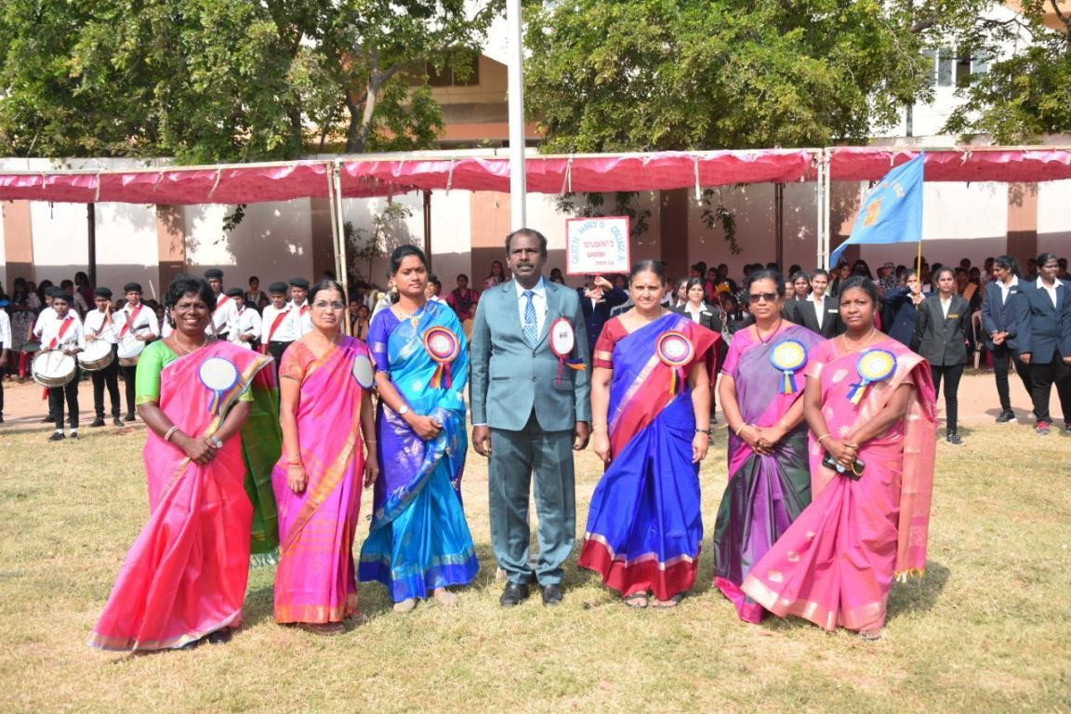

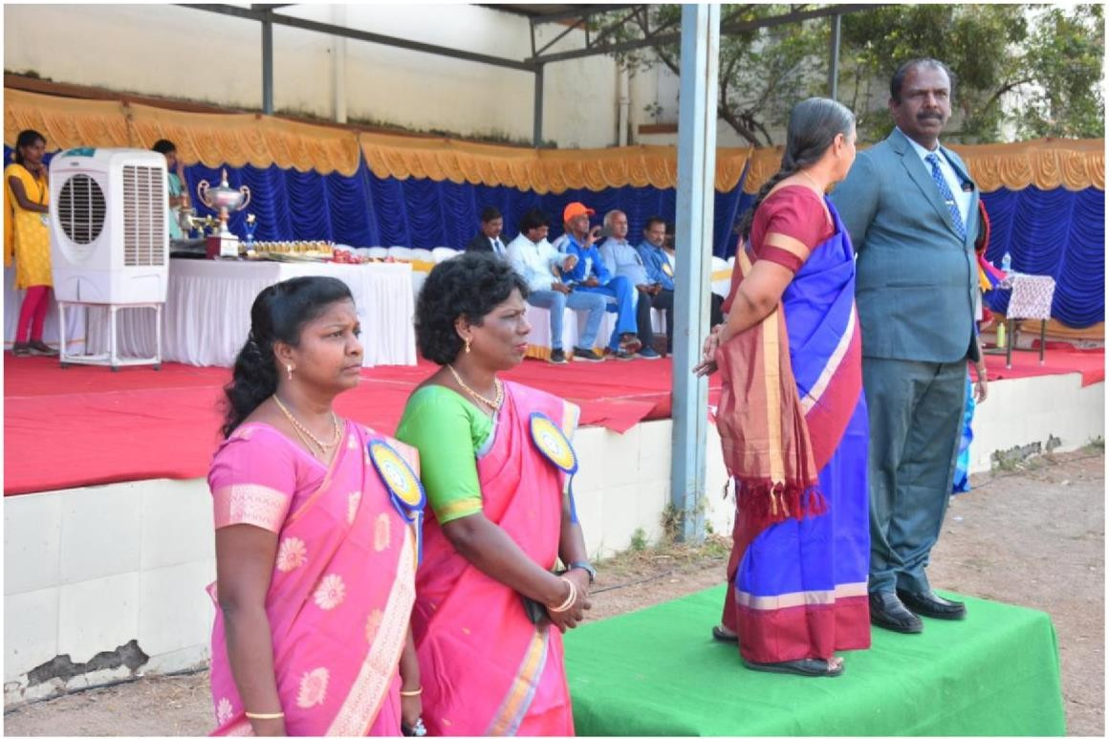

MARCH PAST

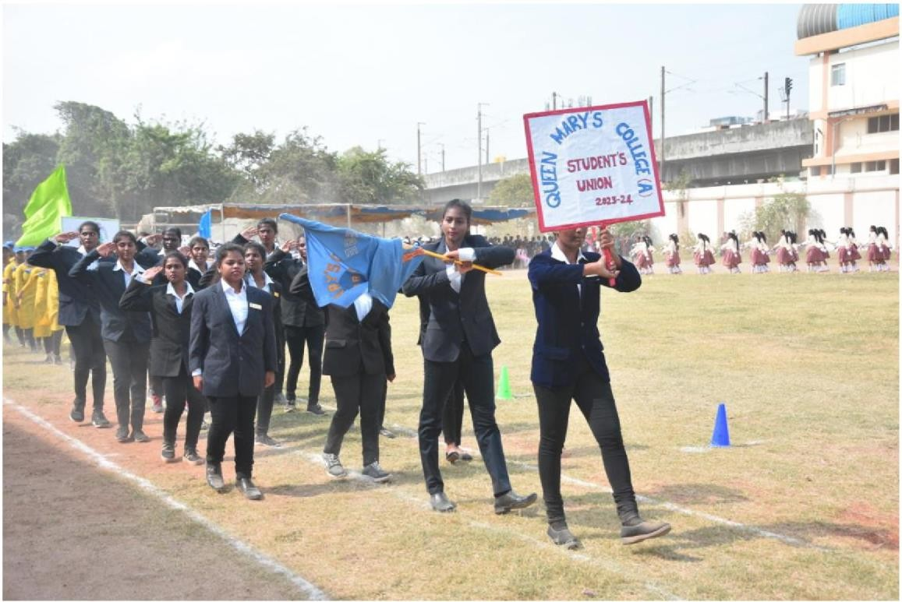

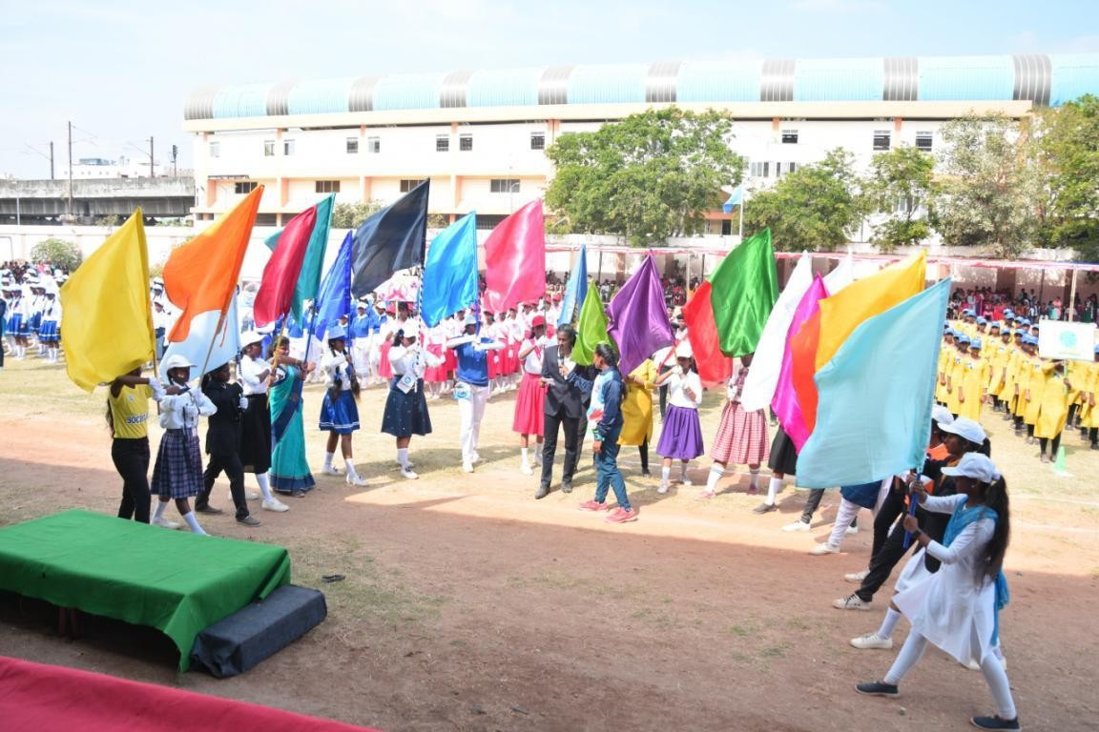 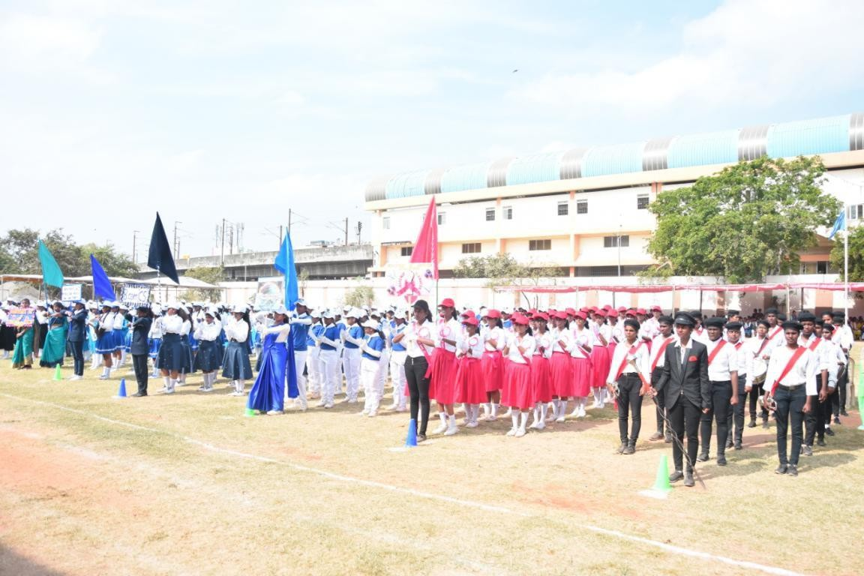

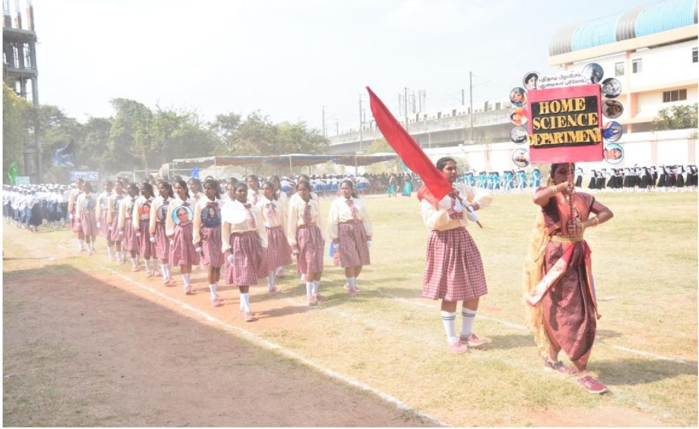

OYLIMPIC **TORCH**

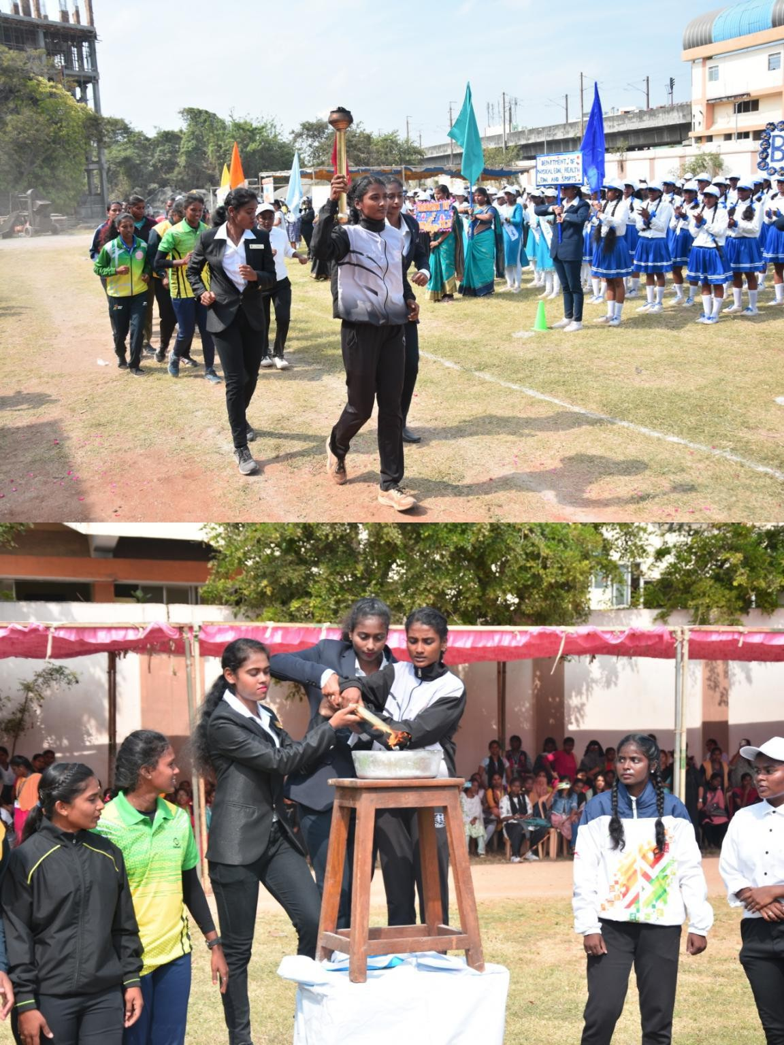

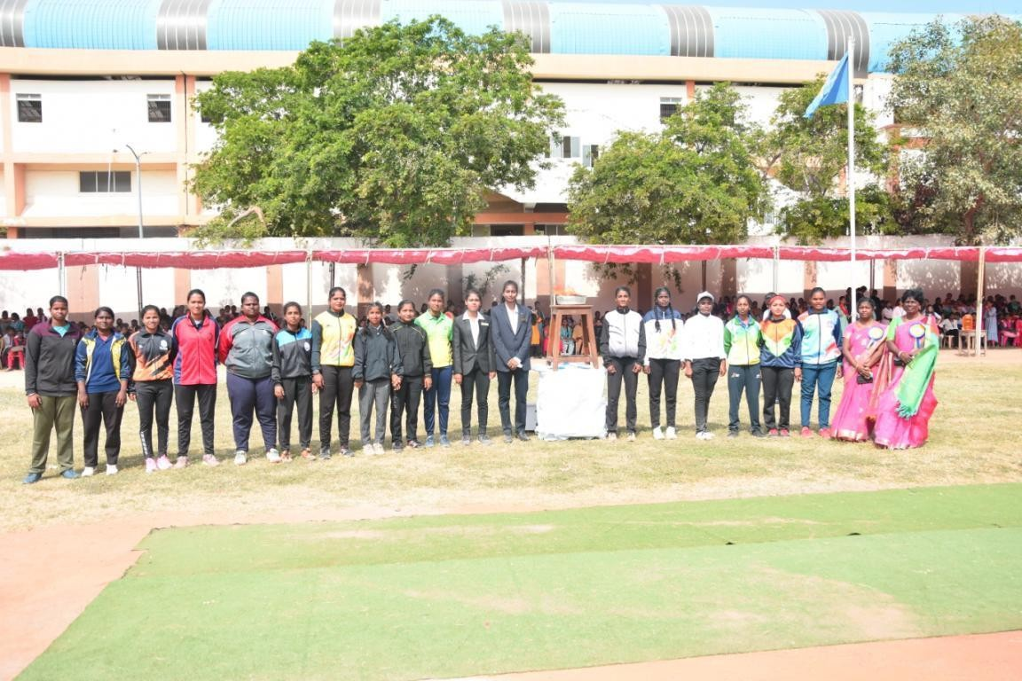

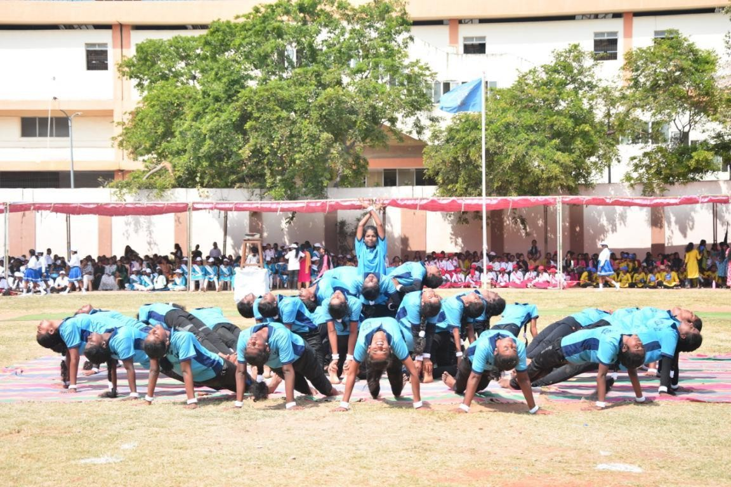

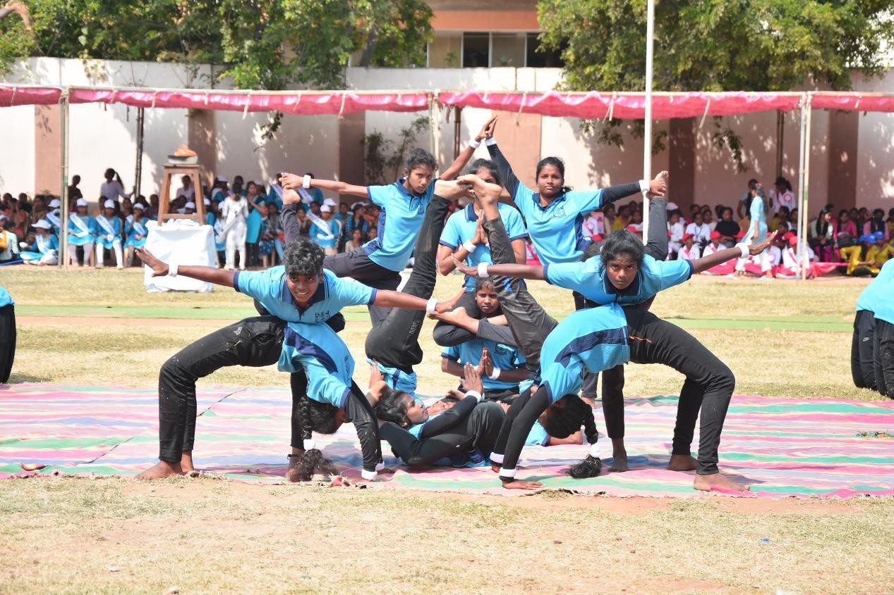

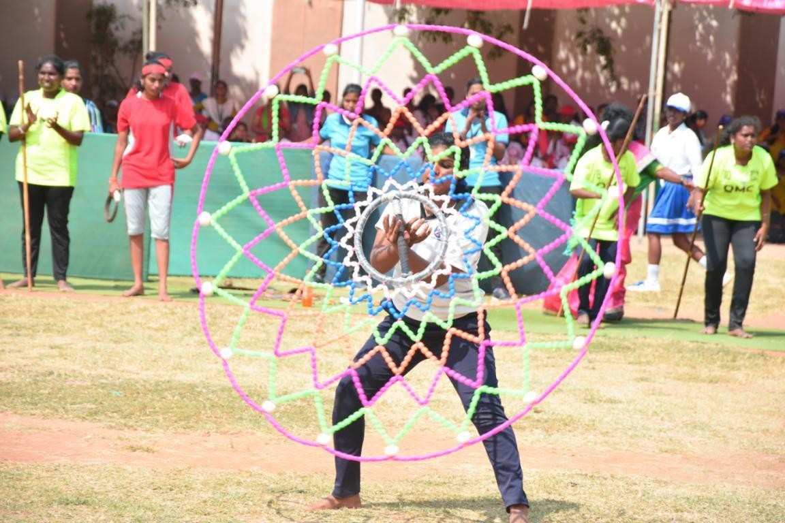

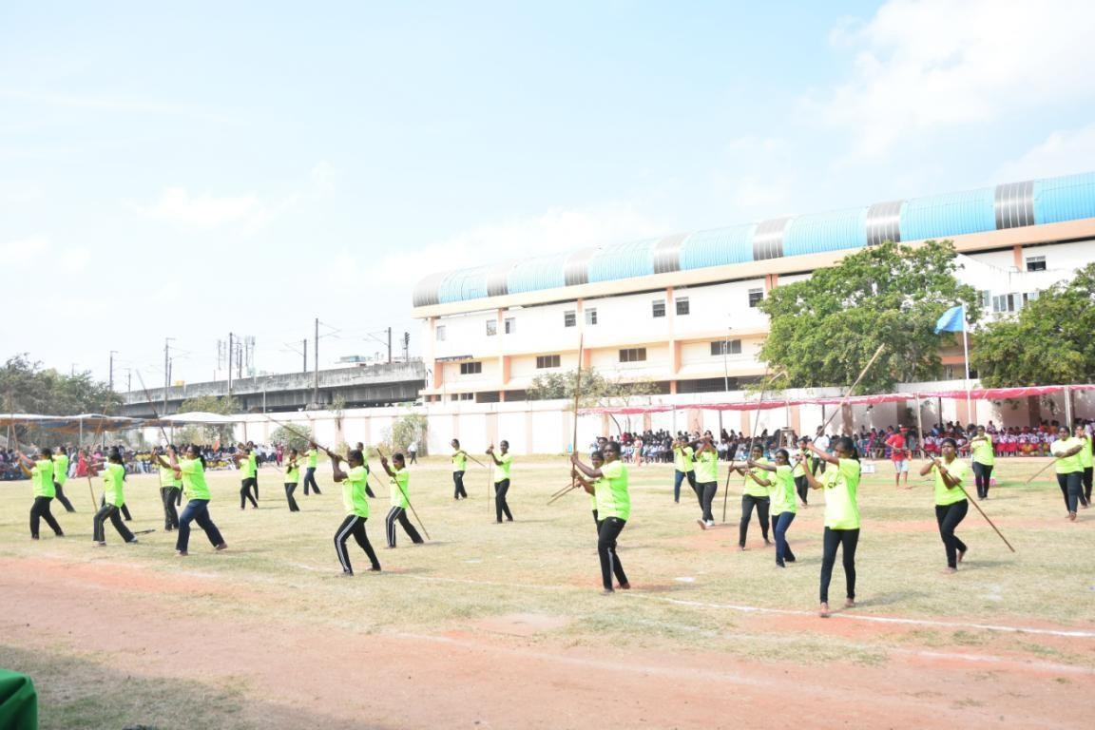

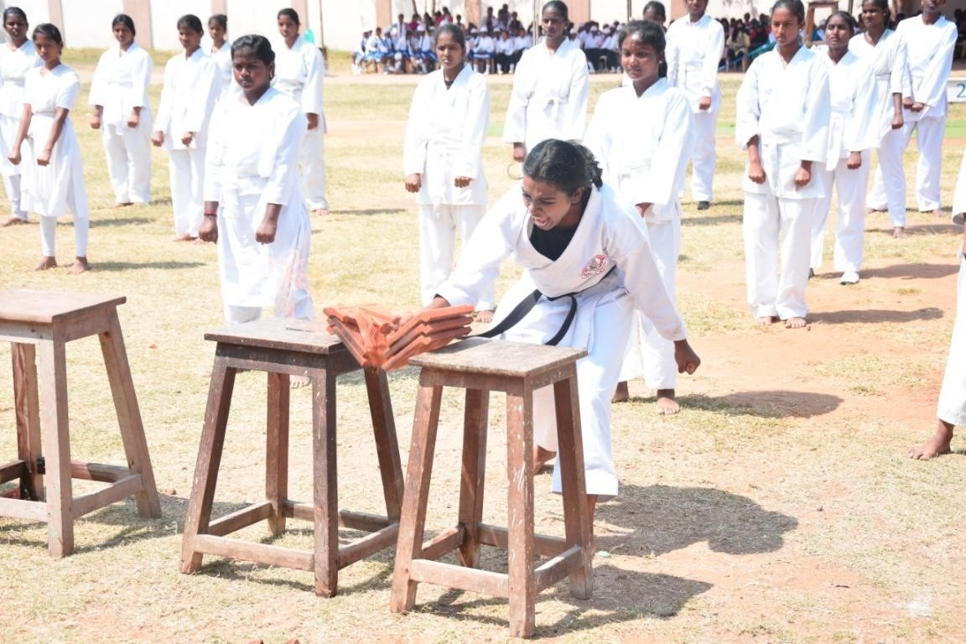

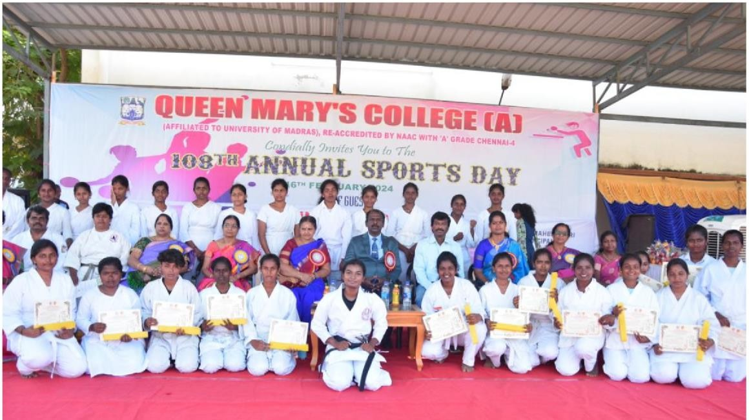

UNION **MEMBERS**

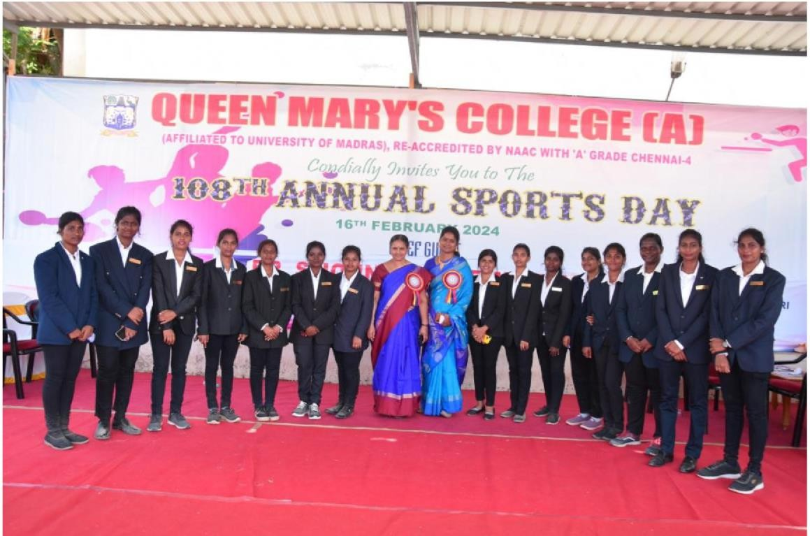

**MARCH PAST WINNER**

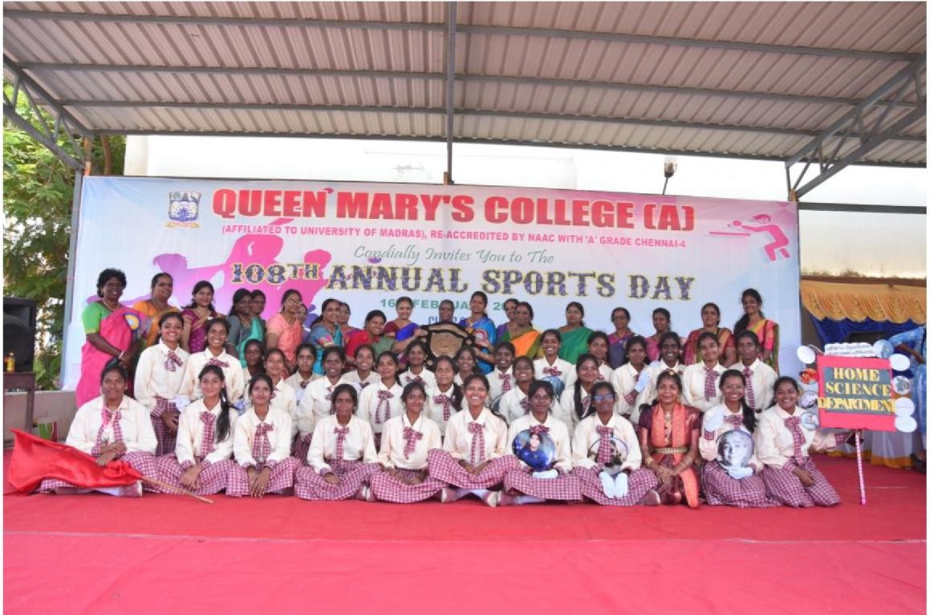**<HOME SCIENCE>**

**OVER ALL WINNER (SOCIOLOGY>**

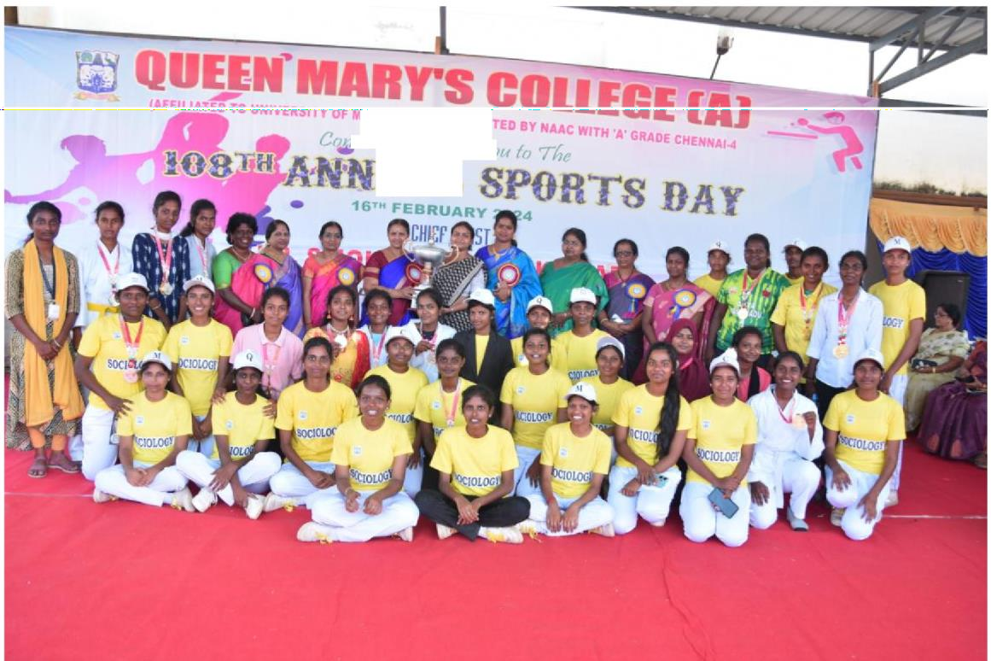

*di ,fly 'Jnvdc,* 7/,

**UAL**

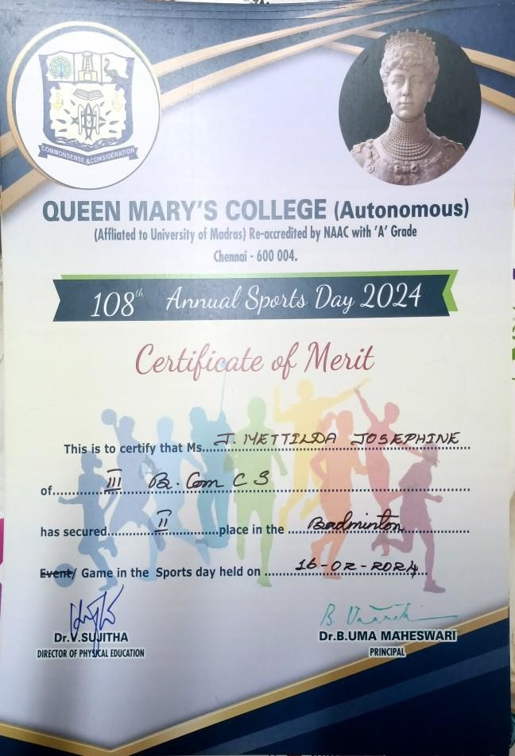



The Tamil Nadu Skill Development Health and Family Welfare Training Centre, Egmore, organized a health workshop on June 22, 2023. The workshop saw enthusiastic participation from sports students showcasing their prowess in various disciplines.

Yoga

17th Yoga Pradarshan South India 2023 at Gummidipoondi Thiruvalluvar witnessed outstanding performances from DPHS students. Umama Maheshwari secured first place, followed by Nandini in second place. Another student from DPHS claimed the third position.

Judo

J. Rosy, a first-year B.Com student, showcased her Judo skills by securing the second position in the Junior Judo State Level Championship at Tirupur. She

also achieved notable positions in national-level competitions, including a 5th position in the Junior National Judo Championship held in Gujarat.

Rugby

The college rugby team clinched the first position in the Touch Rugby Tournament held at Bangalore and secured the second position in both an inter

-college tournament and a tournament jointly organized by the Tamil Nadu Rugby Association and Queen Mary's College.

Pencak Silat

Vijayalakshmi, a first-year B.Com student, represented the college in various national Pencak Silat championships, earning accolades such as a Bronze medal and Silver medals in different events.

Cricket

Three cricket players from the college participated in the Interzone Ticket Tournament, securing the second position.

University Events

The college excelled in various sports at the University of Madras A Zone tournament, securing top positions in Kabaddi and notable performances in other games like football, tennis, and cricket.

Powerlifting

Merlin, a student from the Department of Physical Education, secured the fifth position in the State Level Powerlifting Competition.

Other Achievements

The college's visually challenged students secured the first position in the State Level Chief Minister Trophy Tournament.

Several students represented the college in inter-university tournaments and national-level competitions across different sports, highlighting the diverse talents nurtured within the department.

Dr. Sadhana, an English department professor, represented Tamil Nadu in a

national-level basketball tournament, securing the second position with her team.

*Overall Achievements*

The Department of Physical Education produced an impressive tally of 35 state players, 22 national players, and one international player across various sports.

Conclusion

Congratulations to all the participants for their remarkable achievements, showcasing the dedication and talent fostered within the Department of Physical Education. These accomplishments reflect the college's commitment to promoting sports excellence among its students.